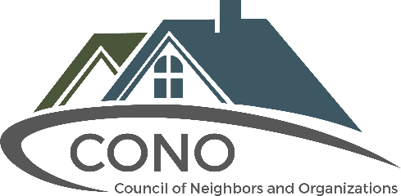
Marketing Coordinator

Title: Marketing Coordinator Reports to: Chief Executive Officer
Summary: The Marketing Coordinator plays a key role in advancing the Council of Neighbors and Organizations (CONO) mission and vision - empowering neighborhoods within the Pikes Peak Region and providing the resources to create neighborhoods that are safe, healthy and thriving places to live. The individual works to increase visibility for CONO, its services and programs, and overall community engagement.
Duties and Responsibilities:
- Assist in developing marketing and outreach strategies to promote CONO programs and services, events, membership, and educational resources.
- Identify and develop content for dissemination to media and across all CONO social media platforms.
- Assist in developing and maintain an annual content calendar.
- Coordinate and produce eNewsletters.
- Coordinate and produce CONO’s social media.
- Provide writing/layout/distribution support related to website, targeted eBlasts, surveys, presentations, event flyers, video production, and other internal and external projects.
- Research and obtain images to support content.
- Monitor print and electronic media coverage of CONO; keep abreast of community news.
- Provide communication support at CONO events (i.e. Facebook Live, live-tweet, Boomerang).
- Provide information and customer service support in response to membership and general public inquiries.
- Set goals, interpret results, and formulate recommendations to improve efficiency.
Required Skills and Qualifications:
- Bachelor’s degree: Marketing, Communications, PR or related field.
- Superior writing and proofreading skills, with attention to detail, grammar and voice
- Ability to produce compelling, concise, accurate and professional content.
- Experience researching information and resources online.
- Exceptional computer skills; proficient in MS Word, Excel, Power Point, InDesign.
- Working knowledge of established social media platforms and programs (i.e. Facebook advertising).
- Advanced technology skills a plus, particularly with content management systems.
- Excellent interpersonal skills; ability to work well with colleagues, media, members, partners and other stakeholders.
- Solid organizational skills; ability to work productively in a fast-paced, collaborative environment managing a multi-faceted workload and meeting deadlines.
- Comfortable with public speaking.
- Capability to anticipate needs, recommend options and implement solutions.
- Ability to work independently and as a team.
- Optimistic attitude and flexibility in changing work environment.
- Passion for building and supporting our community.
- May require occasional travel, weekend and evening work.
- Other duties as assigned.
Benefits: This entry-level position is perfect for an individual interested in helping a local nonprofit build capacity while gaining a broad scope of professional expertise and development of professional and community-connected network.
- Flexible schedule.
- Part time, not to exceed 30 hours per week.
- Potential to become full time opportunity, based upon performance.

Email cover letter and resume to diane@cscono.org

